Project Development Phase
Project Testing & Validation
Date | 15 September 2026
Team ID | Individual
Project Name | Employee Raise Issue – Record Producer & Service Portal Integration Guide
Maximum Marks

Employee Raise Issue Testing:
Project team shall fill the following information in the project testing and validation template.
S.No. | Parameter | Values | Screenshot
1. | Employee Center Portal | The Employee Center portal is created and accessible, with Search, Raise an Issue, Quick Links, My Active Items and Recommended for You. | 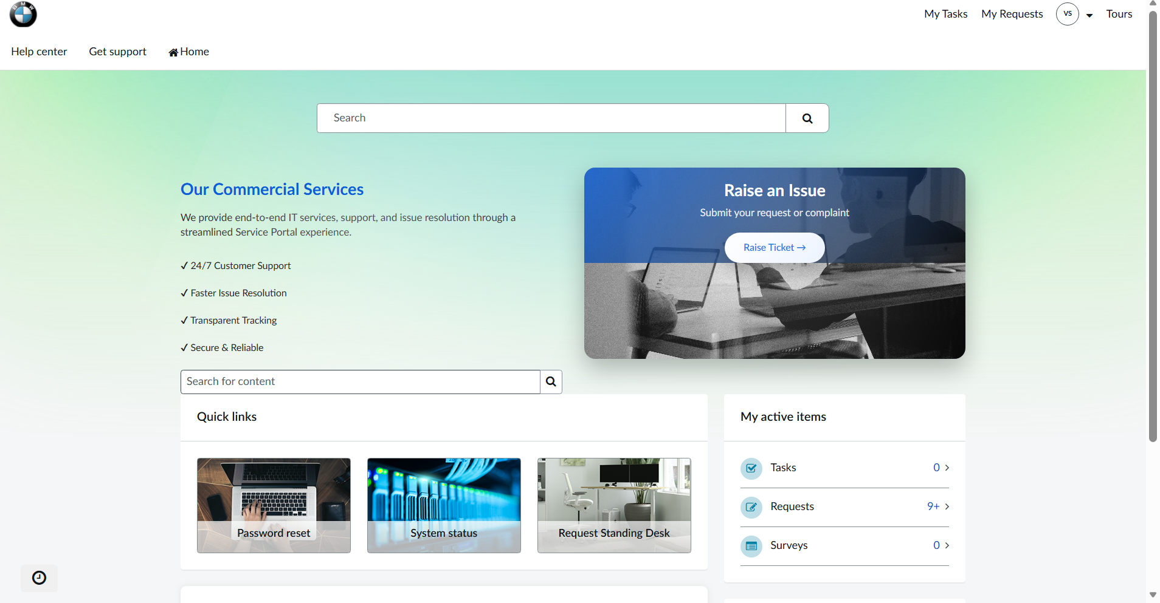
2. | Raise Employee Issue Record Producer | The Raise Employee Issue Record Producer is accessible under Raise an Issue and displays the issue form. | 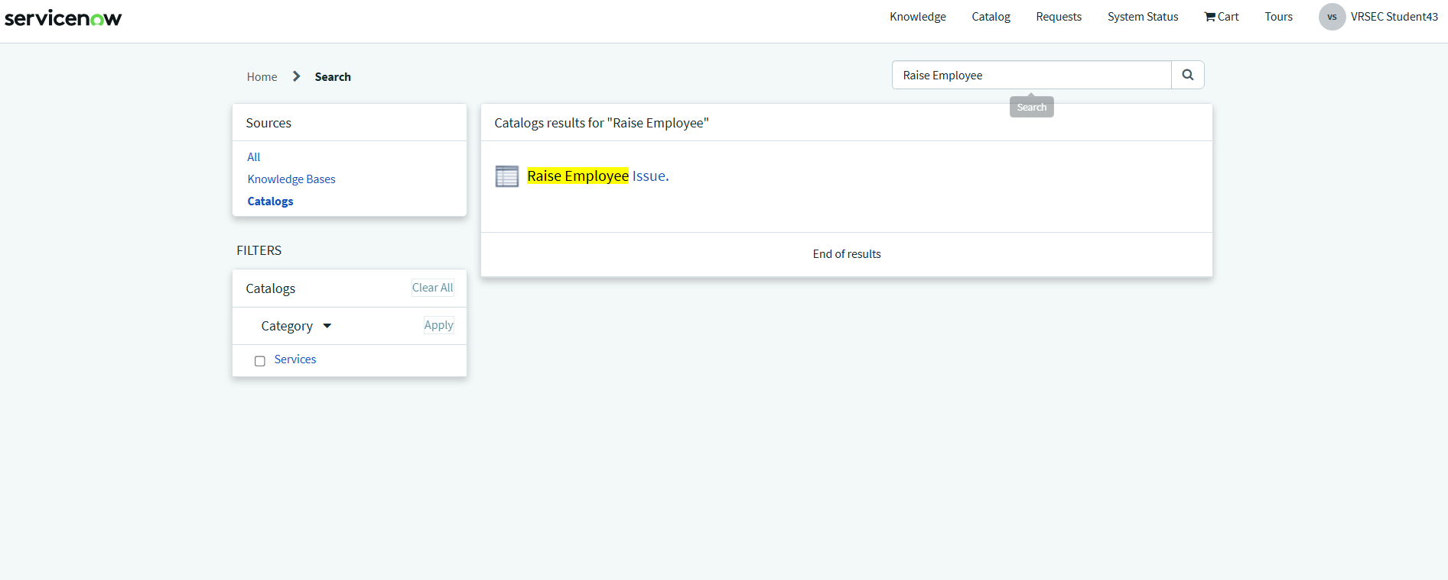
3. | Issue Submission | The employee submits Requester, Category, Subcategory, State and Short Description (attachment if required). | 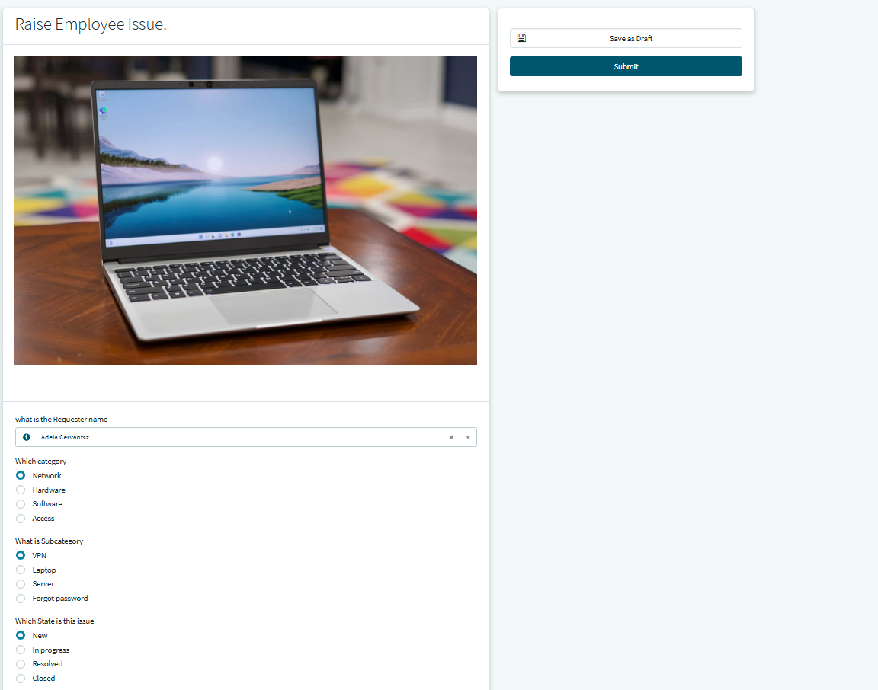
4. | Employee Issue Record | An Employee Issue record is created in the Employee Raise Issue table after submission (e.g. EMP0001004). | 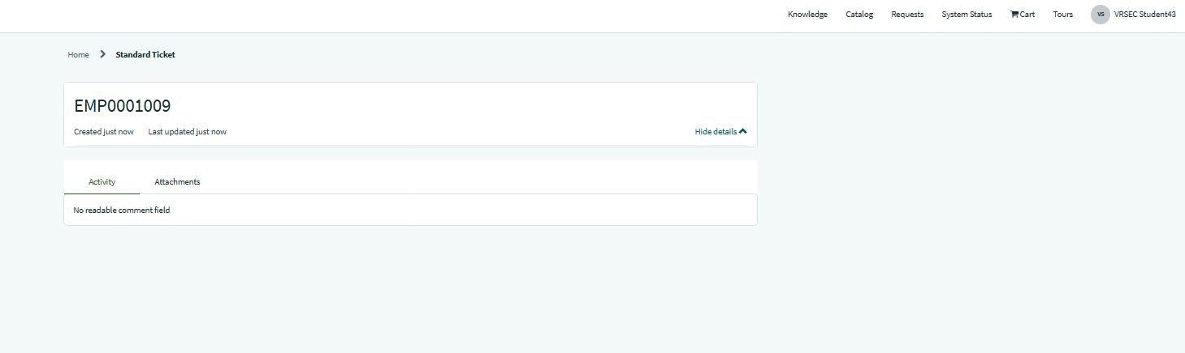
5. | UI Policies / Dependencies | Configured UI policies / dependencies behave correctly for Category / Subcategory and other fields on the form. | 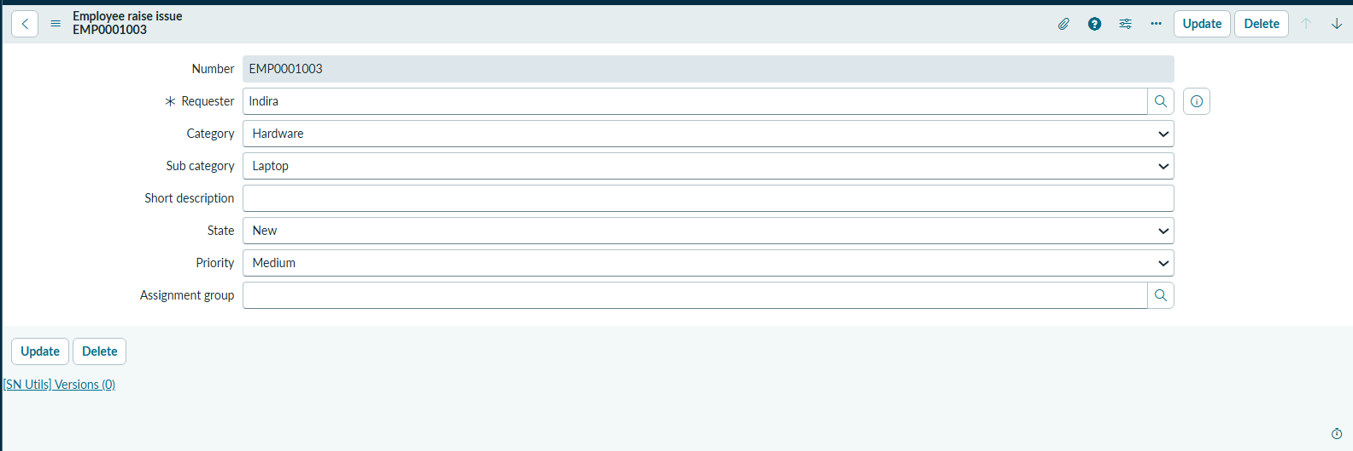
6. | Commercial Services Widget | The custom Commercial Services widget displays “Our Commercial Services” with its styled design on the Employee Center homepage. | 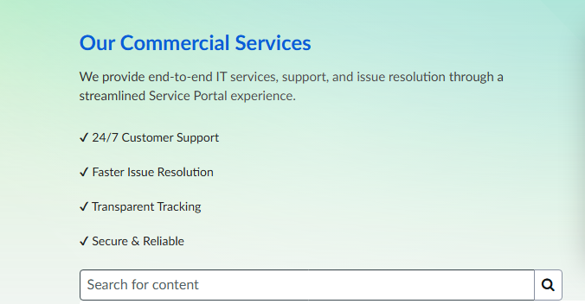
7. | GitHub Repository | The ServiceNow application is committed to the GitHub repository SriyaRam12/employee-issue-management-servicenow. | 